**Cognizant Deep Skilling Mandatory Hands-On Questions**

**TOPIC- Microservices with Spring Boot 3 and Spring Cloud Exercises**

**Exercise 1:** Creating Microservices for account and loan

Ans) (i)For Account

Step1) Go to <https://start.spring.io>

| **Field** | **Value** |
| --- | --- |
| Project | Maven |
| Language | Java |
| Spring Boot | Default |
| Group | com.cognizant |
| Artifact | account |
| Name | account |
| Packaging | Jar |
| Java | 17 (or your installed version) |

* **Add Dependencies :** Spring Web & Spring Boot DevTools

And generate it

Step2) Download the zip file, extract it and import into your Java Compiler (IntelliJ in my case)

Step3) Create AccountController class in ‘src/main/java/com/cognizant/account’ 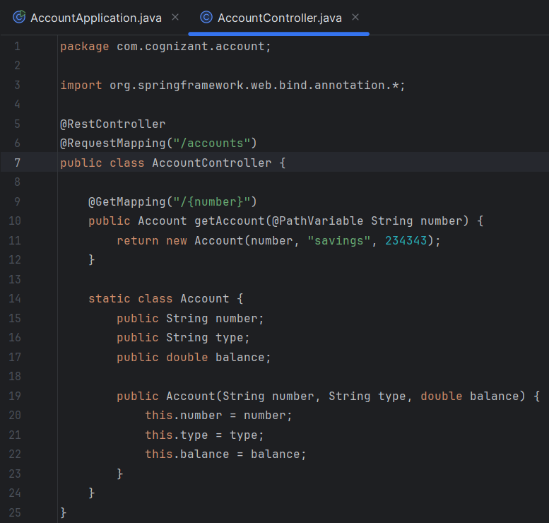

Step4) Run ‘AccountApplication.java

Step5) Open browser : <http://localhost:8080/accounts/12345>

**OUTPUT** 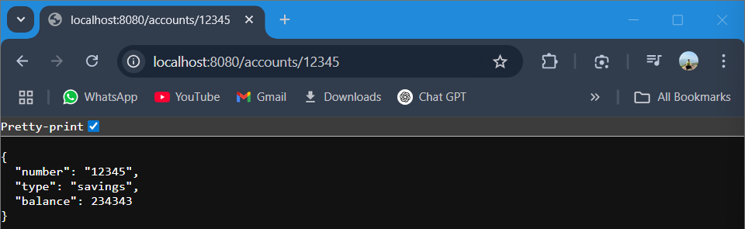

(ii)For Loan

Step1) Same process as of previous exercise for account, just change the Artifact and Name from account to “loan”

Step2) Same as previous exercise for account

Step3) Create Loan Controller in ‘src/main/java/com/cognizant/loan/LoanController.java’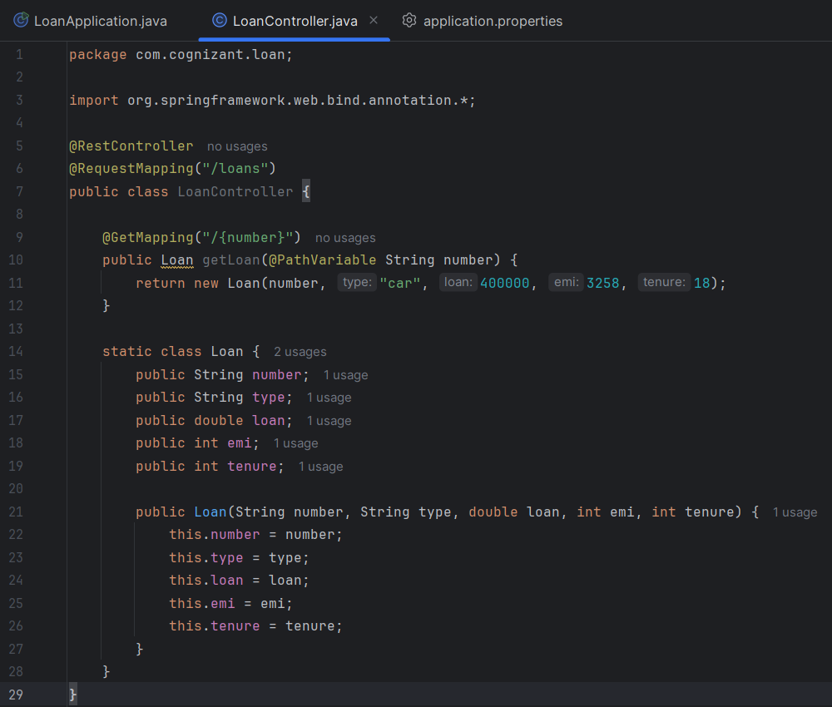

Step4) Change Port for Loan Microservice in ‘loan/src/main/resources/application.properties’ add ‘server.port=8081’  
 Because AccountApplication.java runs on port 8080

Step5) Open browser : http://localhost:8081/loans/H1234

